**~ Sacred Women’s Circles ~**

**6 Week Series ~ Birthing Spirit Center ~ Sedgwick, Maine**

**April9th - May 14th 6:30-9:00 pm**

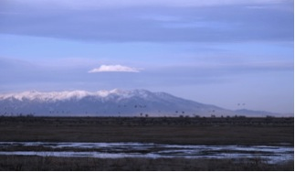

**Facilitator: Susan Jenkins**

**Shamanic Healer ~ Medicine Dreamer**

**An invitation for women to gather in circle to deepen our connection to divine spirit, our true “essence” and sacred moon lodge within. Our time together will include meditation, guided shamanic journeying, earth practices, journaling and sharing.**

Susan has years of experience in holding and facilitating women’s circles with integrity and heart. There has always been a strong yearning in women for the collective power, support, inspiration, and sisterhood that women in circle create. Susan strives to hold a sacred, safe, and nurturing container in which women can listen, support and witness one another as we birth in to and embody our true life’s purpose and vision.

6 weeks : $210 (payments accepted)

A $35 non-refundable deposit is encouraged to hold your space.

For more information please contact:

Susan Jenkins [susanjenkinsurban@gmail.com](mailto:susanjenkinsurban@gmail.com)

207-359-4626 Cell: 207-266-8598

shamanichealingwork.com

Photo/ Susan: Sand Hill Crane Migration, Monte Vista, Colorado April, 2012 *

Crane Medicine:Intelligence, discipline, vigilance, magic, astral travel, reaching deeper mysteries and truths;traveling, in search of spiritual wisdom.