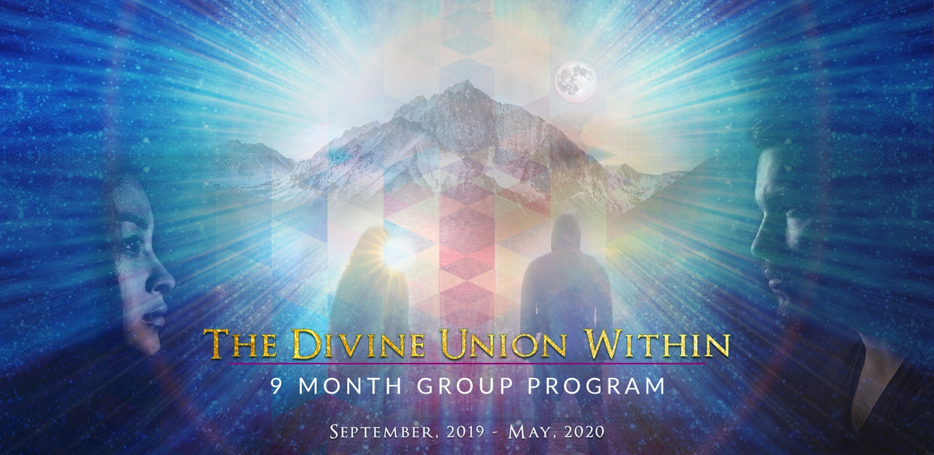
An Inner Warrior Journey of Self Love and Empowerment through Healing and Cultivating the Sacred Union of the Divine Masculine and Feminine Within
I’m so excited to offer my newly inspired group program, for women and men ready to fully empower their lives through consummating The Divine Union Within.
During our 9 months you’ll:
- Liberate yourself from patriarcal chains, false beliefs, stories and disempowering myths that still influence your life.
- Explore your relationship with the masculine and feminine energies inside you.
- Learn how to navigate the intricate dance of these archetypal forces and energies.
- Learn about the balancing powers of the Sun and Moon Lodge.
- Ground yourself with the Earth and the Cosmic Medicine Wheel for stability, strength and inner power.
- Explore the relationship between your inner woman and man and learn ways to nourish their divine union within.
- Learn to cherish yourself and become your own beloved, first and foremost. Claim your inner power, autonomy and divine sovereignty.

9 MONTH PROGRAM INCLUDES:
Retreat on Mount Desert Island Maine September 17th -19th, 2019
3 Live group video Zoom calls each month
Secret “Divine Union” Facebook Forum
Plus 3 personal sessions with Susan (Value: $1,500)
$500 down $697/month Total Investment: $6,773

